Запросы к базе данных

1. SELECT
g.ID_Game,
g.Title,
g.Price,
g.Platform,
g.Developer,
COUNT(ak.ID_Activation_Key) AS 'Доступно ключей'
FROM Game g
JOIN Activation_Key ak ON g.ID_Game = ak.Game_ID
WHERE ak.Status = 'available'
GROUP BY g.ID_Game, g.Title, g.Price, g.Platform, g.Developer
ORDER BY g.Title;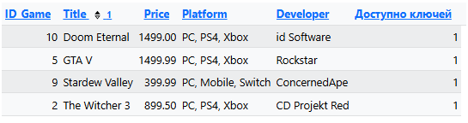

2. -- 1. Создаём платёж (pending)
INSERT INTO Payment (Payment_Date, Amount, Payment_Method, Payment_Status)
VALUES (NOW(), 4405.00, 'card', 'pending');
SET @payment_id = LAST_INSERT_ID();

-- 2. Создаём заказ, привязанный к этому платежу
INSERT INTO `Order` (Order_Date, Total_Amount, Order_Status, Payment_ID, Customer_ID)
VALUES (NOW(), 4405.00, 'pending', @payment_id, 1);
SET @order_id = LAST_INSERT_ID();

-- 3. Получаем ID доступного ключа Pragmata
SET @key_id = (SELECT ID_Activation_Key FROM Activation_Key WHERE Game_ID = 1 AND Status = 'available' LIMIT 1);
-- 4. Добавляем позицию в заказ
INSERT INTO Order_Item (Order_ID, Activation_Key_ID, Price_At_Purchase)
VALUES (@order_id, @key_id, 4405.00);
-- 5. Резервируем ключ
UPDATE Activation_Key SET Status = 'reserved' WHERE ID_Activation_Key = @key_id;

3. SELECT
o.ID_Order AS 'Заказ',
o.Order_Status AS 'Статус заказа',
p.Payment_Status AS 'Статус платежа',
ak.Status AS 'Статус ключа'
FROM `Order` o
JOIN Payment p ON o.Payment_ID = p.ID_Payment
JOIN Order_Item oi ON o.ID_Order = oi.Order_ID
JOIN Activation_Key ak ON oi.Activation_Key_ID = ak.ID_Activation_Key
JOIN Game g ON ak.Game_ID = g.ID_Game
WHERE g.ID_Game = 1
ORDER BY o.ID_Order DESC
LIMIT 1;
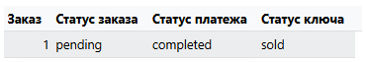

4. UPDATE Payment SET Payment_Status = 'completed' WHERE ID_Payment = @payment_id;
UPDATE `Order` SET Order_Status = 'completed' WHERE ID_Order = @order_id;
UPDATE Activation_Key SET Status = 'sold' WHERE ID_Activation_Key = @key_id;

5. SELECT
o.ID_Order AS 'Номер заказа',
o.Order_Date AS 'Дата',
o.Total_Amount AS 'Сумма',
o.Order_Status AS 'Статус',
g.Title AS 'Игра',
g.Platform,
ak.Key_Code AS 'Ключ',
p.Payment_Method AS 'Метод оплаты',
p.Payment_Status AS 'Статус оплаты'
FROM `Order` o
JOIN Order_Item oi ON o.ID_Order = oi.Order_ID
JOIN Activation_Key ak ON oi.Activation_Key_ID = ak.ID_Activation_Key
JOIN Game g ON ak.Game_ID = g.ID_Game
JOIN Payment p ON o.Payment_ID = p.ID_Payment
WHERE g.ID_Game = 1
ORDER BY o.ID_Order DESC
LIMIT 1;

